

**Faculty of engineering - Shoubra**

**Benha University**

# Research Article

in fulfillment of the requirements of

|  |  |
| --- | --- |
| **Department** | **Engineering Mathematics and Physics** |
| **Division** | **-----------------** |
| **Academic Year** | **2019-2020 Preparatory** |
| **Course name** | **Computer** |
| **Course code** | **ECE006** |

## Title: -

**Build a website on Programming languages**

By:

|  |  |  |  |
| --- | --- | --- | --- |
|  | Name | Edu mail | B.N |
| 1 | نديم اسامة عبدالغني | Nadeem196106@feng.bu.edu.eg | 981 |

**Approved by:**

|  |  |
| --- | --- |
| Examiners committee | Signature |
|  |  |
|  |  |
|  |  |
|  |  |
|  |  |

# Research objectives

Learn about programming languages and what they are and learn some information about some programming languages such as c and c ++ and python and learn how to create a site in HTML

# Abstract

A programming language is a formal language comprising a set of instructions that produce various kinds of output. Programming languages are used in write computer programs, which involves a computer performing some kind of computation or algorithm and possibly control external devices such as printers, disk drives, robots, and so on

Programming languages share properties with natural languages related to their purpose as vehicles for communication, having a syntactic form separate from its semantics, and showing language families of related languages branching one from another.

Most programming languages consist of instructions for computers. There are programmable machines that use a set of specific instructions, rather than general programming languages.

# Table of contents

|  |  |
| --- | --- |
| **Subject / section** | **Page** |
| **Article** | **6,7** |
| **github’s links** | **6** |
| **Screen shoots for source code** | **8,9** |
| **Screen shoots for the website** | **10,11** |

**List of Figures (If any)**

|  |  |  |
| --- | --- | --- |
| **Figure I.D** | **Description** | **Page** |
| **1,2,3** | **Screen shoots for source code** | **8,9** |
| **4,5,6** | **Screen shoots for the website** | **10,11** |

# Introduction

A programming language can be divided into two groups: high-level programming languages and low-level programming languages.

High-level programming languages are easier to code in. the syntax is closer to how we think and speak which makes it easier to write. When we say the term programming language, we mostly mean high-level programming languages such as Java, Ruby or Python.

Low-level programming languages on the other hand are more difficult to code in.

Some of the advantages of using it is that the program can be run much faster. The code which was written needs to be processed much less and is understood by the computer much faster. Such as assembly language and machine language.

There are also languages such as C and C++ which are considered middle-level programming languages.

# Article

Computer programming language, any of various languages for expressing a set of detailed instructions for a digital computer. Such instructions can be executed directly when they are in the computer manufacturer specific numerical form known as machine language, after a simple substitution process when expressed in a corresponding assembly language, or after translation from some “higher-level” language. Although there are many computer languages, relatively few are widely used. And there are some of it

The C programming language was developed for programming computer operating systems. Its capacity to structure data and programs through the composition of smaller units is comparable to that of ALGOL. It uses a compact notation and provides the programmer with the ability to operate with the addresses of data as well as with their values.

The C++ language, developed in the mid-1980s, extended C by adding objects to it while preserving the efficiency of C programs. It has been one of the most important languages for both education and industrial programming.

Python is an advanced programming language that is interpreted, object-oriented and built on flexible and robust semantics.

## Screen shoots for the source code

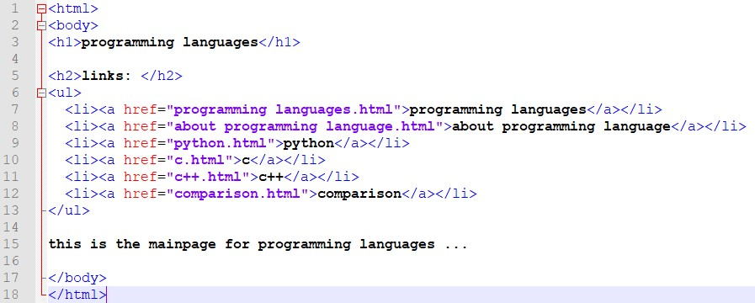

(1)

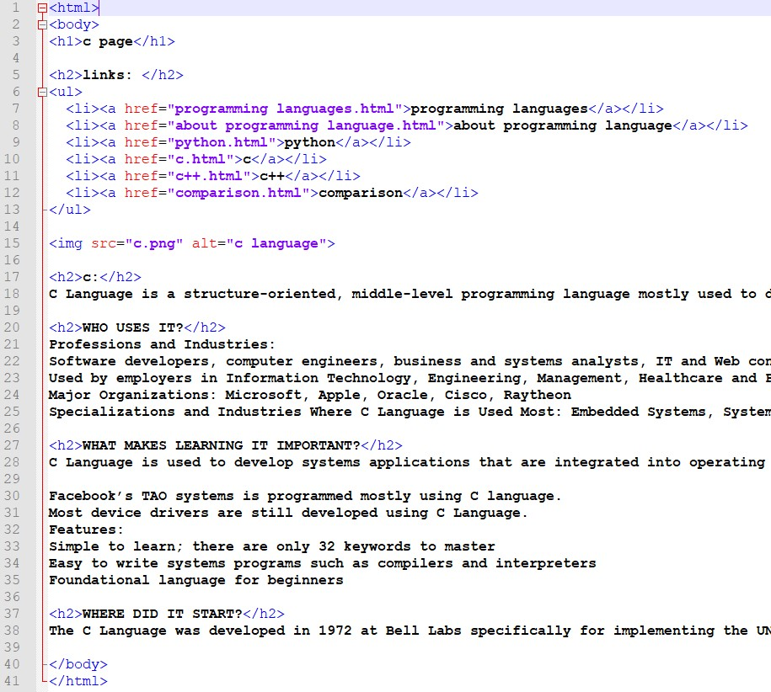(2)

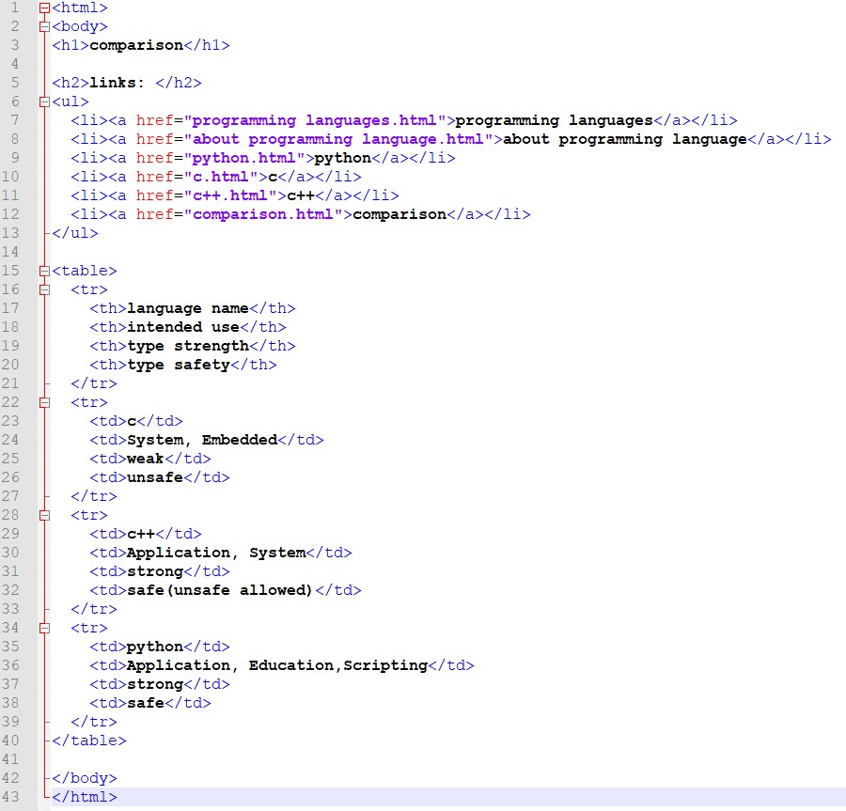

**(3)**

## Screen shoots for the website

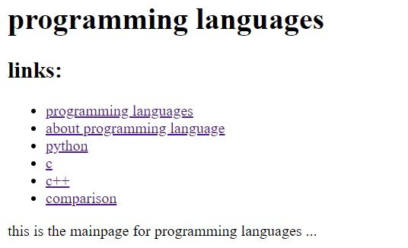

4

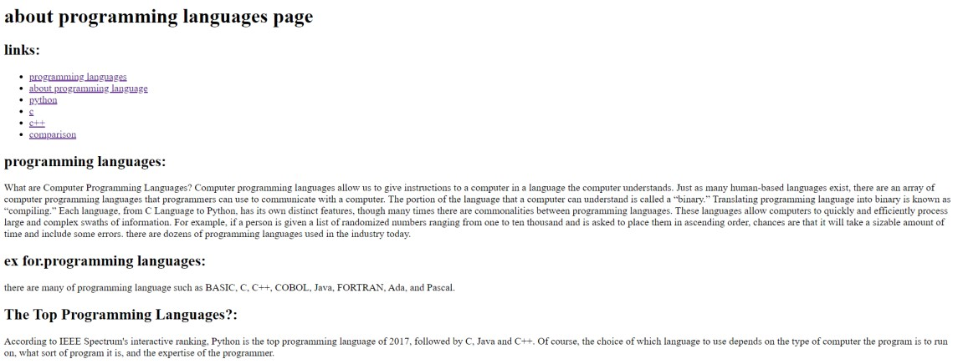

5

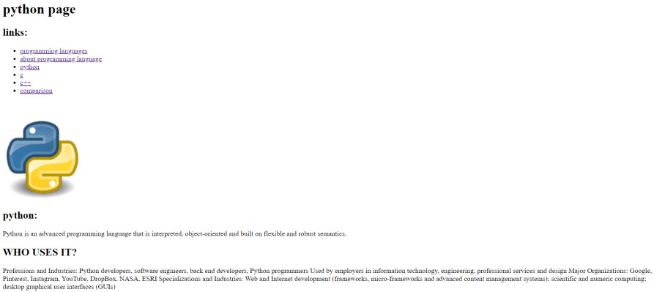

6

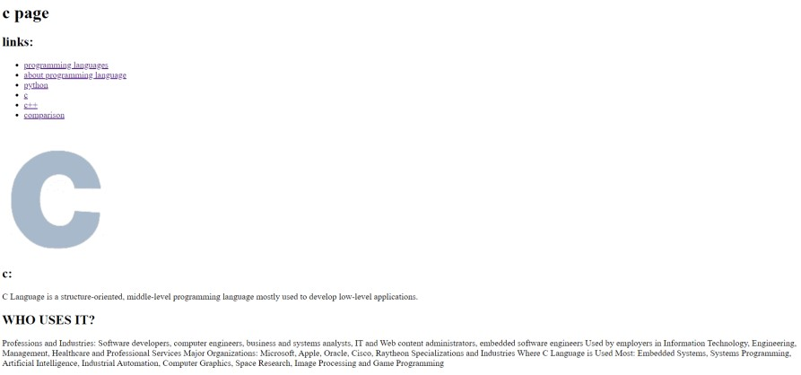

# References

-Aaby, Anthony (2004). Introduction to Programming Languages. Archived from the original on 8 November 2012. Retrieved 29 September 2012.

-In mathematical terms, this means the programming language is Turing-complete MacLennan, Bruce J. (1987). Principles of Programming Languages. Oxford University Press. p. 1. ISBN 978-0-19-511306-8.

[https://www.webopedia.com/TERM/P/programming_lan guage.html](https://www.webopedia.com/TERM/P/programming_language.html) [https://www.computerscience.org/resources/computerprogramming-languages/](https://www.computerscience.org/resources/computer-programming-languages/) file:///C:/Users/Nadeem%20Sakr/Downloads/Documents /lang.pdf